One page Webpage

Take current text content and option from each field from the page <http://autoins.saveonautoinsurance.us/>

Must have at the bottom Term of Use and Privacy Policy

Car information: Attached file

Drop down menu where they can choose from top to bottom, Year, and then Make will be filter by all Makers on that year, then all models made on that year and make. Database will be provided in excel file

Insured company: Drop down list provided in excel file.

First name and Lastname: Must have a validator that check if the person is typing special characters, show the error in red.

Date of Birth: Must have a calendar option when clicked on, with easy access to years, Months and days. Format YYYY-MM-DD

Gender: Male and Female

Street Address: Text Box

Zip: 5 digits validator, if customer puts 4 digits then add a 0 at the beginning (ex: 4321 = 04321)

Phone: 10 numerical digits validator, customer can type but the final format must be (321) 775 – 3456

Email: email validator, must have @ and “.” To be considered a good email.

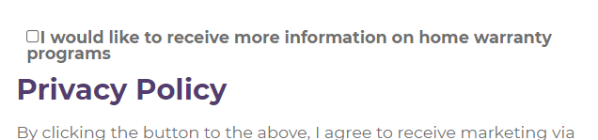

I would like to receive more information on home warranty programs: must be unchecked.

Select Education: Default to “High school diploma”

Select Occupation: Default to “Sel Employed”

Select Credit Rating: Default to “Good”

Select Married: Default to “Married”

License Active: Yes

Filing Required: Yes

Tickets Or Claims In The Last 3 Years?: Default to “No”

Continuously Covered For: More than 5 years

Do you own your home?: Default Yes

Estimated year built: 2005 – Newer

Estimated square foot page: 1000 – 2000

Number Of Stories: Default 2

The page Must have the Jornaya code implemented. Attached file

All information must be saved in the SQL server, together with the Jornaya LeadID, and all information from the customer, IP address, device, and browser information.

Admin portal where we can have basic reports on the page, phone search, Date search and export report option with all fields.

This page has to work with the robot, making sure it has all access needed to work, making sure the Jornaya code works fine and not catch that is a robot filling out the form. Including all robot features, specially Ip address thru proxy.